=

Public holiday Guide
  - Mental Health
victorian hospital's industrial association – FEB 2024

introduction
The purpose of this Public Holiday Guide is to replace the previous Public Holiday Matrices and summarise the public holiday entitlements afforded to employees under the Victorian Public Health Sector Mental Health Services Enterprise Agreement 2022 – 2024 (Agreement) for the remaining life of the Agreement until it is replaced.
Members will no longer receive multiple Public Holiday Matrices throughout the year, rather members can use this document to prepare for all public holidays for the remaining life of the Agreement.
VHIA has detailed the known public holidays that occur between the publication date of this Public Holiday and the nominal expiry date of the Agreement, 31 December 2024. VHIA will provide updated advice to members closer to that date where the Agreement is anticipated to operate beyond the nominal expiry date.
It is not intended to replace the Agreement or provide an entitlement beyond the Agreement itself.
VHIA encourages members to read the relevant terms of the Agreement alongside this Public Holiday Matrix.

where to find copies of the agreement and other material
VHIA members can access copies of the Agreement and other material (such as Implementation Guides and Salary Circulars) by selecting Mental Health under ‘My Professions’ on your VHIA Website Dashboard.
For more information about accessing the VHIA Website, please contact vhia@vhia.com.au

WHO TO CONTACT FOR MORE INFORMATION
Members are encouraged to direct any queries in relation to this Public Holiday Guide to query@vhia.com.au

REGISTERED PSYCHIATRIC NURSES/ PSYCHIATRIC ENROLLED NURSES AND MENTAL HEALTH OFFICERS

working on a public holiday
Relevant Clause
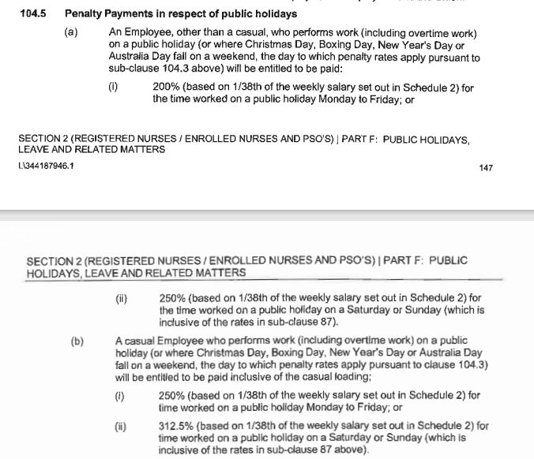

working on a public holiday- NIGHT SHIFT

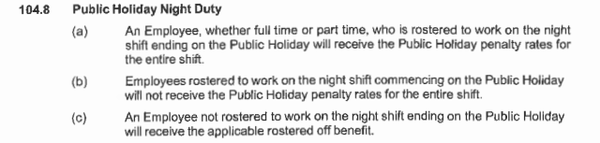

not working on a public holiday – FULL TIME
Relevant Clause
Note: The definition of Actual Day and Other Day can be found summarised below under Additional Rules – Public Holidays falling on a Weekend

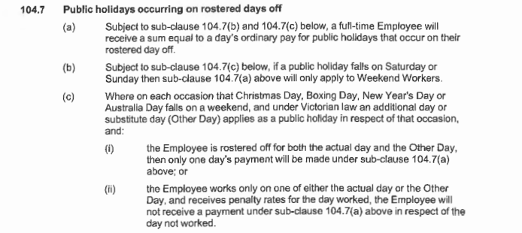

not working on a public holiday – Part TIME

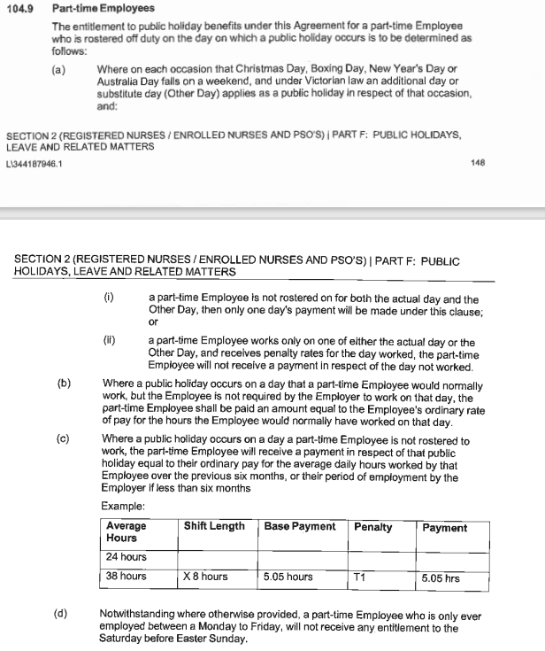

additional rules – public holidays falling on weekend
Relevant Clause
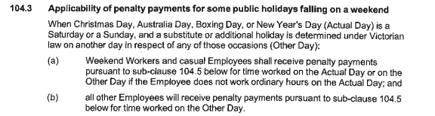

additional rules – other leave on public holidays
Leave Type | Impact of taking leave on a Public Holiday
Annual Leave | If an Employee takes paid annual leave during a period that includes a public holiday, the Employee is taken not be on paid annual leave on that day – see sub-clause 101.7
Personal Leave | If the period during which an Employee takes paid personal leave includes a day or part day that is a public holiday in the place where the Employee is based for work purposes, the Employee is taken not to be on paid personal leave on that public holiday– see subclause 102.9
Long Service Leave | Long service leave is inclusive of (not additional to) any public holiday or ADO occurring during the period when leave is taken - see subclause 47.8
Paid Parental Leave | An Employee on Paid Parental Leave when a public holiday occurs does not receive a public holiday entitlement, nor does it extend the Paid Parental Leave period
Unpaid Leave | If an employee is on Unpaid Leave when a Public Holiday occurs, the employee does not receive a public holiday entitlement.

additional rules – recall on public holiday
Relevant Clause
Note: This clause provides that an employee who has an entitlement to a public holiday benefit on a day they are not working will be guaranteed the rostered off benefit afforded to them under subclause 104.3 and 104.7 in addition to any recall payment they receive – regardless of the time of the day the recall occurs.

Table 1: Summary of Public Holiday Entitlements REGISTERED PSYCHIATRIC NURSES/ PSYCHIATRIC ENROLLED NURSES AND MENTAL HEALTH OFFICERS
NOTE: Employees in receipt of Commuted Allowance do not receive any Public Holiday benefits
Night Shifts: Where the shift ends on a public holiday, public holiday penalty payment to applies for the entire shift worked - e.g. 10 hr shift = 10 hrs public holiday penalties Where the shift commences on a public holiday, no public holiday penalties apply ordinary time rates apply to the entire shift.
Full Time | Entitlement | Clause Ref.
Rostered to Work (works on public holiday) | 200% or 250% if it falls on a Saturday or Sunday | 104.5
Rostered to Work (not required to work) | 1 days ordinary pay at the rostered hours for that day | 104.1
Not Rostered to Work (rostered day off) | 1 days ordinary pay (7.6 hours unless they ordinarily work longer shifts)  Weekend PH (e.g. Easter Saturday and Easter Sunday):  Employees who are Weekend Workers receive the Not Rostered to Work benefit set out above (100%)  No rostered off penalty applicable if the employee is not a Weekend Worker  Weekend Worker means an Employee who works ordinary hours on a Saturday or Sunday | 104.7  104.7(a) and (b)  104.11

Part Time | Entitlement | Clause Ref.
Rostered to Work (works on public holiday) | 200% or 250% if it falls on a Saturday or Sunday | 104.5
Rostered to Work (not required to work) | 1 days ordinary pay at the rostered hours for that day | 104.1
Not Rostered to Work (rostered day off) | Weekdays & Weekend PH (including Easter Saturday)  Pro-rata payment, equal to their ordinary pay for the average daily hours worked by that employee over the previous six months (e.g. 24  /38 x 8 hours (or usual shift length) = 5.05 hours.  E.g. a part-time Employee who is only ever  employed between a Monday to Friday, will not receive any entitlement to Easter Saturday or Easter Sunday. | 104.9 (b)(c) and (d)

Casual | Entitlement | Clause Ref.
Rostered to Work | 250% or 312.5% if it falls on a Saturday or Sunday | 104.5
Not Rostered to Work | No rostered off benefit unless they are required to work on that day | Silent

Health proFessionals

working on a public holiday
Relevant Clause
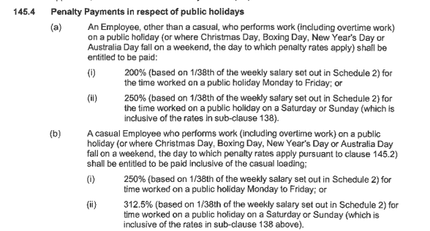

not working on a public holiday

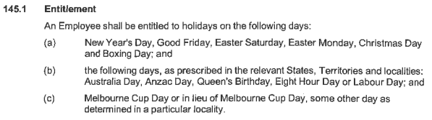

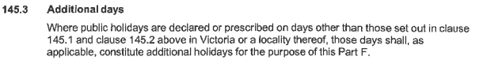

additional rules – other leave on public holidays
Leave Type | Impact of taking leave on a Public Holiday
Annual Leave | If an Employee takes paid annual leave during a period that includes a public holiday, the Employee is taken not be on paid annual leave on that day – see sub-clause 143.7
Personal Leave | If the period during which an Employee takes paid personal leave includes a day or part day that is a public holiday in the place where the Employee is based for work purposes, the Employee is taken not to be on paid personal leave on that public holiday
Long Service Leave | Long service leave is inclusive of (not additional to) Public Holidays that occur during the relevant period of leave
Paid Parental Leave | An Employee on Paid Parental Leave when a public holiday occurs does not receive a public holiday entitlement, nor does it extend the Paid Parental Leave period
Unpaid Leave | If an employee is on Unpaid Leave when a Public Holiday occurs, the employee does not receive a public holiday entitlement.

aDDITIONAL rULES – CONVERSION OF PUBLIC HOLIDAYS TO LEAVE
Relevant Clause
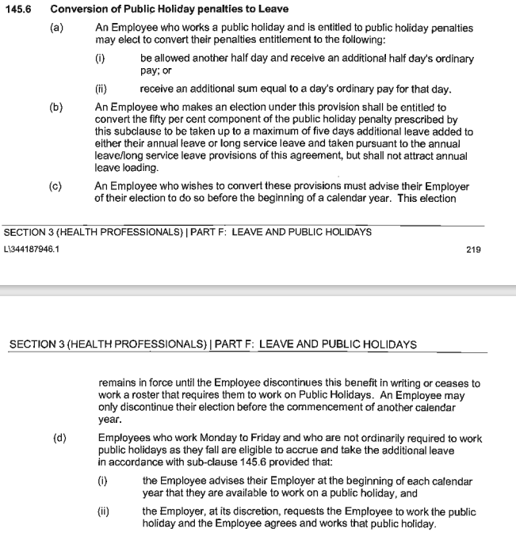

Table 1: Summary of Public Holiday Entitlements – mENTAL HEALTH: HEALTH PROFESSIONALS

Full Time | Entitlement | Clause Ref.
Rostered to Work (works on public holiday) | 200% or 250% if it falls on a Saturday or Sunday or may elect their penalties converted to another half day and receive an additional half days ordinary pay | 145.4 and 145.6
Rostered to Work (not required to work) | 1 days ordinary pay at the rostered hours for that day | 145.1
Not Rostered to Work (rostered day off) | 1.5 days ordinary pay or within 4 weeks of the public holiday the employee may take 1.5 days TIL or have 1.5 days added to annual leave  Weekend PH (excl. Easter Saturday) (e.g. Easter Sunday):  Employees who are ordinarily required to work on the day that the public holiday falls (the Saturday or the Sunday) receive the Not Rostered to Work benefit set out above (100%)  The entitlement does not extend to workers who may ordinarily work on a Saturday (but not a Sunday) and the Public Holiday falls on the Sunday (and vice-versa).  E.g. Employee ordinarily works Saturdays (but not Sundays), the employee would not be entitled to a rostered off benefit on Easter Sunday.  No rostered off penalty applicable if the employee is ordinarily not required to work on a Sunday or  Saturday.  Easter Saturday only:  Employees who work Monday to Friday only (must work every day) and don’t work on Easter Saturday are entitled to 1 days ordinary pay, or, with mutual consent, 1 day added to A/L balance or 1 day off in lieu | 145.6  145.5(d)  145.5(i)  145.5(e)

Part Time | Entitlement | Clause Ref.
Rostered to Work (works on public holiday) | 200% or 250% if it falls on a Saturday or Sunday or may elect their penalties converted to another half day and receive an additional half days ordinary pay | 145.4 and 145.6
Rostered to Work (not required to work) | 1 days ordinary pay at the rostered hours for that day | 145.1
Not Rostered to Work | Weekdays & Weekend PH (excl. Easter Saturday)  No clear entitlement, to be used as a guide only.  Over the preceding 6 months if an employee has worked 50% or more of the days on which a particular Public Holiday falls, the employee shall be entitled to receive the "rostered off" benefit for that Public Holiday (150%)  No rostered off penalty applicable if the employee is ordinarily not required to work on a Sunday or  Saturday.  Easter Saturday only:  Employees who work Monday to Friday only (must work every day) and don’t work on Easter Saturday are entitled to 1 days ordinary pay, or, with mutual consent, 1 day added to A/L balance or 1 day off in lieu | Silent  145.5(i)  145.5(e)

Casual | Entitlement | Clause Ref.
Rostered to Work | 250% or 312.5% if it falls on a Saturday or Sunday | 145.4
Not Rostered to Work | No rostered off benefit unless they are required to work on that day | Silent

Health and allied services

working on a public holiday
Relevant Clause
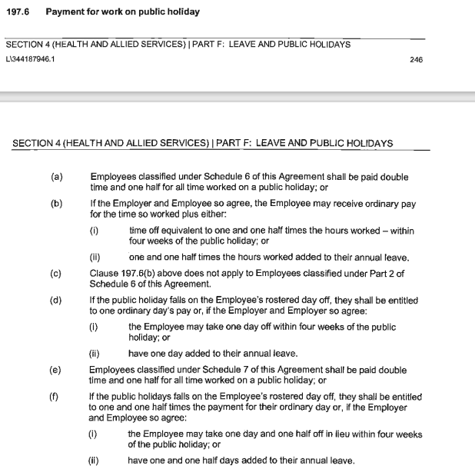

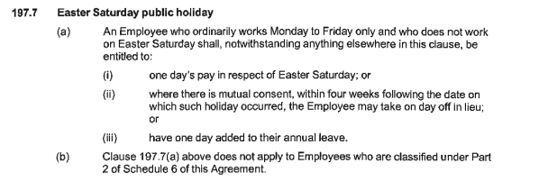

not working on a public holiday – FULL TIME
Relevant Clause
Note: The definition of Actual Day and Other Day can be found summarised below under Additional Rules – Public Holidays falling on a Weekend
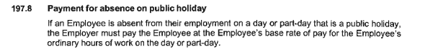

not working on a public holiday – Part TIME

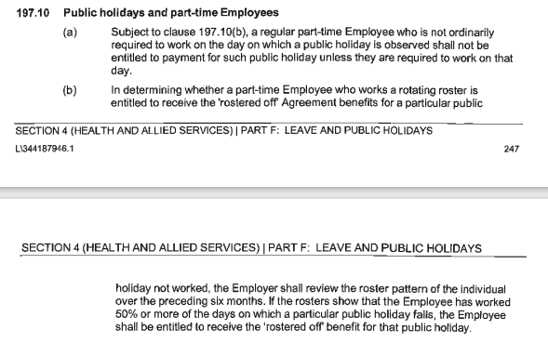

additional rules – public holidays falling on weekend
Relevant Clause
Please refer to working on a public holiday above. Sub-clause 197.6 and 197.7

additional rules – other leave on public holidays
Leave Type | Impact of taking leave on a Public Holiday
Annual Leave | Where a public holiday occurs during a period when an Employee is on annual leave, the Employee is taken not to be on annual leave on that public holiday – see sub-clause 195.3
Personal Leave | If the period during which an Employee takes paid personal leave includes a day or part-day that is a public holiday in the place where the Employee is based for work purposes, the Employee is taken not to be on paid personal leave on that public holiday– see subclause 196.8
Long Service Leave | Long service leave is inclusive of (not additional to) Public Holidays that occur during the relevant period of leave -Silent
Paid Parental Leave | An Employee on Paid Parental Leave when a public holiday occurs does not receive a public holiday entitlement, nor does it extend the Paid Parental Leave period
Unpaid Leave | If an employee is on Unpaid Leave when a Public Holiday occurs, the employee does not receive a public holiday entitlement.

additional rules – recall on public holiday
Relevant Clause
Note: This clause provides that an employee who has an entitlement to a public holiday benefit on a day they are not working will be guaranteed the rostered off benefit afforded to them in addition to any recall payment they receive – regardless of the time of the day the recall occurs.

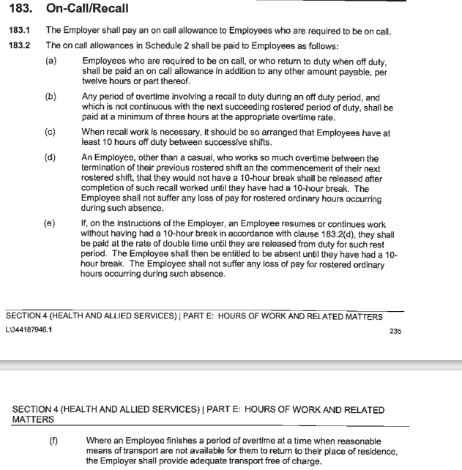

Table 1: Summary of Public Holiday Entitlements

Full Time | Entitlement | Clause Ref.
Rostered to Work (works on public holiday) | 250%  Or  1 days Ordinary pay + 1.5 time off equivalent to the hours worked on the public holiday, to be taken as TIL within 4 weeks or added to annual leave by mutual consent | 197.6
Rostered to Work (not required to work) | 1 days Ordinary Pay based on the hours the employee was rostered to work | 197.1
Not Rostered to Work (rostered day off) | Weekdays & Weekend PH (excl. Easter Saturday)  1.5 times their ordinary day or 1.5 days off in lieu within four weeks of the public holiday or 1.5 days added to A/L balance  Easter Saturday only  Employees who work Monday to Friday only (must work every day) and don’t work on Easter Saturday are entitled to 1 days ordinary pay, or, with mutual consent, 1 day added to A/L balance or 1 day off in lieu | 197.6(d)  197.7

Part Time | Entitlement | Clause Ref.
Rostered to Work (works on public holiday) | 250% | 197.6
Rostered to Work (not required to work) | 1 days Ordinary Pay based on the hours the employee was rostered to work | 197.1
Not Rostered to Work (rostered day off or other day off) | Weekdays & Weekend PH (excl. Easter Saturday)  1.5 times their ordinary day or 1.5 days off in lieu within four weeks of the public holiday or 1.5 days added to A/L balance  Note, this will only apply to employees who are ordinarily required to work on the day which the public holiday was observed. This is determined by reviewing the preceding 6 month roster, if an employee has worked 50% or more of the days on which a particular Public Holiday falls, the employee shall be entitled to receive the "rostered off" benefit for that Public Holiday)  An employee who is not ordinarily required to work on the day on which a public holiday is observed will not be entitled to the Rostered Off Benefit)  Easter Saturday only  Employees who work Monday to Friday only (must work every day) and don’t work on Easter Saturday are entitled to 1 days ordinary pay, or, with mutual consent, 1 day added to A/L balance or 1 day off in lieu | 197.6(d)  197.10(b)  197.10(a)  197.7

Casual | Entitlement | Clause Ref.
Rostered to Work | 175% | 25.4 (e)
Not Rostered to Work | No rostered off benefit unless they are required to work on that day | Silent

MANAGEMENT AND ADMINISTRATIVE WORKERS

working on a public holiday
Relevant Clause
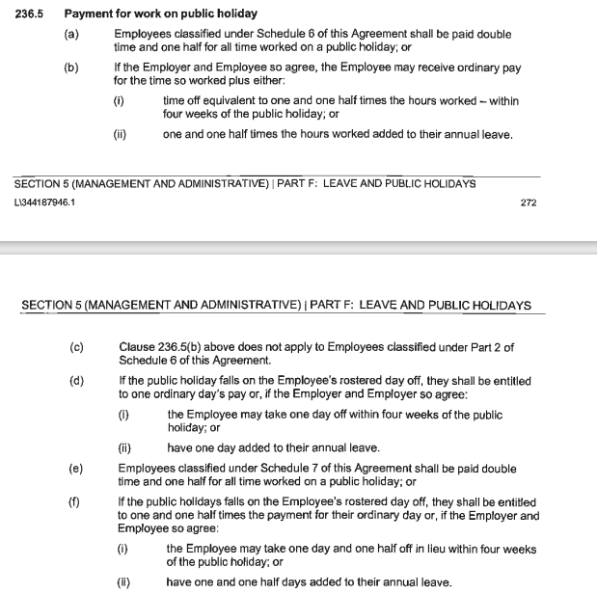

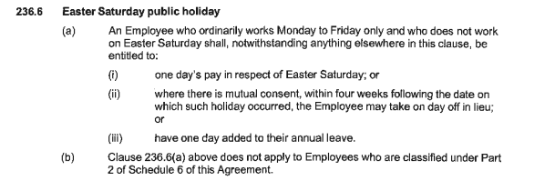

not working on a public holiday – FULL TIME
Relevant Clause
Note: The definition of Actual Day and Other Day can be found summarised below under Additional Rules – Public Holidays falling on a Weekend
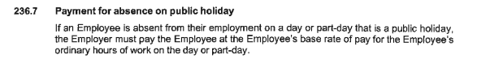

not working on a public holiday – Part TIME

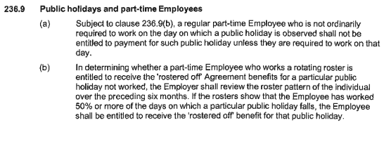

additional rules – public holidays falling on weekend
Relevant Clause
Please refer to working on a public holiday above. Sub-clause 236.5 and 236.6

additional rules – other leave on public holidays
Leave Type | Impact of taking leave on a Public Holiday
Annual Leave | Where a public holiday occurs during a period when an Employee is on annual leave, the Employee is taken not to be on annual leave on that public holiday – see sub-clause 232.3
Personal Leave | If the period during which an Employee takes paid personal leave includes a day or part-day that is a public holiday in the place where the Employee is based for work purposes, the Employee is taken not to be on paid personal leave on that public holiday– see subclause 235.6
Long Service Leave | Long service leave is inclusive of (not additional to) Public Holidays that occur during the relevant period of leave -Silent
Paid Parental Leave | An Employee on Paid Parental Leave when a public holiday occurs does not receive a public holiday entitlement, nor does it extend the Paid Parental Leave period
Unpaid Leave | If an employee is on Unpaid Leave when a Public Holiday occurs, the employee does not receive a public holiday entitlement.

additional rules – recall on public holiday
Relevant Clause
Note: This clause provides that an employee who has an entitlement to a public holiday benefit on a day they are not working will be guaranteed the rostered off benefit afforded to them in addition to any recall payment they receive – regardless of the time of the day the recall occurs.

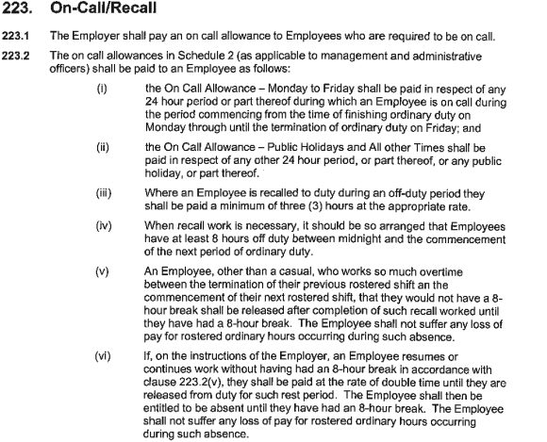

Table 1: Summary of Public Holiday Entitlements

Full Time | Entitlement | Clause Ref.
Rostered to Work (works on public holiday) | 250% or (provided in sub-clause 236.5(b)) 100% + 1.5 days added to A/L balance or 100% + 1.5 days off within four weeks of the public holiday  (Sub-clause 236.5(b) does not apply to employees classified under Part 2 of Schedule 6 of the agreement) | 236.5
Rostered to Work (not required to work) | 1 days Ordinary Pay based on the hours the employee was rostered to work | 236.1
Not Rostered to Work (rostered day off) | Weekdays & Weekend PH (excl. Easter Saturday)  1 days ordinary pay (7.6 hours unless they ordinarily work longer shifts) or 1 day off in lieu within four weeks of the public holiday or 1 day added to A/L balance  Easter Saturday only  Employees who work Monday to Friday only (must work every day) and don’t work on Easter Saturday are entitled to 1 days ordinary pay, or, with mutual consent, 1 day added to A/L balance or 1 day off in lieu.  This does not apply to employees classified under Part 2 of Schedule 6 of the Agreement) | 236.5(d)  236.6

Part Time | Entitlement | Clause Ref.
Rostered to Work (works on public holiday) | 250% or (provided in sub-clause 236.5(b)) 100% + 1.5 days added to A/L balance or 100% + 1.5 days off within four weeks of the public holiday  (Sub-clause 236.5(b) does not apply to employees classified under Part 2 of Schedule 6 of the agreement) | 236.5
Rostered to Work (not required to work) | 1 days Ordinary Pay based on the hours the employee was rostered to work | 236.1
Not Rostered to Work (rostered day off) | Weekdays & Weekend PH (excl. Easter Saturday)  1 days ordinary pay (7.6 hours unless they ordinarily work longer shifts) or 1 day off in lieu within four weeks of the public holiday or 1 day added to A/L balance  Note, this will only apply to employees who are ordinarily required to work on the day which the public holiday was observed. This is determined by reviewing the preceding 6 month roster, if an employee has worked 50% or more of the days on which a particular Public Holiday falls, the employee shall be entitled to receive the "rostered off" benefit for that Public Holiday)  An employee who is not ordinarily required to work on the day on which a public holiday is observed will not be entitled to the Rostered Off Benefit)  Easter Saturday only  Employees who work Monday to Friday only (must work every day) and don’t work on Easter Saturday are entitled to 1 days ordinary pay, or, with mutual consent, 1 day added to A/L balance or 1 day off in lieu | 236.9  236.9(b)  236.9(a)  236.8

Casual | Entitlement | Clause Ref.
Rostered to Work | 175% | 25.4 (e)
Not Rostered to Work | No rostered off benefit unless they are required to work on that day | Silent

Table 2: public holidays occuring until nominal expiry date

Note: Public Holidays falling on a weekend are marked in bold
2024
New Years Day – 1 January 2024 | Australia Day – 26 January 2024
Labour Day – 11 March 2024 | Good Friday – 29 March 2024
Saturday before Easter Saturday – 30 March 2024 | Easter Sunday – 31 March 2024
Easter Monday -1 April 2024 | ANZAC Day – 25 April 2024
King’s Birthday – 10 June 2024 | Friday before AFL Grand Final – 27 September 2024
Melbourne Cup – 5 November 2024 | Christmas Day – 25 December 2024
Boxing Day – 26 December 2024
Source - Victorian public holidays 2024 | Business Victoria

Melbourne Cup Day is a public holiday across all of Victoria unless alternate local holiday has been arranged by a non-metro council.

